A Field Project Report on

**BITE BUZZ**

**Submitted**

*In partial fulfillment of the requirements for the award of the degree*

**BACHELOR OF TECHNOLOGY**

**In**

**COMPUTER SCIENCE and ENGINEERING**

By

K.Sadhika (231FA04E44)

Satyam (231FA04F37)

G.Bharath (231FA04F42)

L.Thanmai (231FA04G78)

Under the Guidance of

**Ch. Swarana Lalitha**

**Assistant Professor, CSE**



**DEPARTMENT OF COMPUTER SCIENCE & ENGINEERING**

**SCHOOL OF COMPUTING AND INFORMATICS**

**VIGNAN'S FOUNDATION FOR SCIENCE, TECHNOLOGY & RESEARCH**

**(Deemed to be University)**

**Vadlamudi, Guntur -522213, INDIA.**

**April, 2025**



**CERTIFICATE**

This is to certify that the field project entitled *“****Bite Buzz****”* is being submitted by [K.Sadhika], [231FA04E44], [Satyam] [231FA04F37], [G.Bharath], [231FA04F42], and [L.Thanmai], [231FA04G78] in partial fulfilment of the requirements for the degree of Bachelor of Technology (B.Tech.) in Computer Science and Engineering at Vignan’s Foundation for Science, Technology and Research (Deemed to be University), Vadlamudi, Guntur District, Andhra Pradesh, India.

This is a bonafide work carried out by the aforementioned students under my guidance and supervision.

**Guide**

**Project Review Committee HoD, CSE**



**DECLARATION**

**Date:**

We hereby declare that the work presented in the field project titled “**Bite Buzz**” is the result of our own efforts and investigations.

This project is being submitted under the supervision of **, Designation** in partial fulfillment of the requirements for the Bachelor of Technology (B.Tech.) degree in Computer Science and Engineering at Vignan’s Foundation for Science, Technology and Research (Deemed to be University), Vadlamudi, Guntur, Andhra Pradesh, India.

|  |  |  |
| --- | --- | --- |
| K.Sadhika | (231FA04E44) | Signature |
| Satyam | (231FA04F37) | Signature |
| G.Bharath | (231FA04F42) | Signature |
| L.Thanmai | (231FA04G78) | Signature |

TABLE OF CONTENTS

|  |  |  |
| --- | --- | --- |
| Chapter No. | Contents | Page No |
| 1 | **Introduction** | 1-3 |
| 1.1 | Problem Definition |  |
| 1.2 | Existing System |  |
| 1.3 | Proposed System |  |
| 1.4 | Literature Review |  |
| 2 | **System Requirements** | 4-5 |
| 2.1 | Hardware & Software Requirements |  |
| 2.2 | Software Requirements Specification(SRS) |  |
| 3 | **System Design** | 6-9 |
| 3.1 | Architectural Design |  |
| 3.2 | UML Diagrams Used |  |
| 3.3 | User Interface Design |  |
| 3.4 | Modules of System |  |
| 3.5 | UML Diagrams |  |
| 4 | **Implementation** | 10-14 |
| 4.1 | Source Code |  |
| 5 | **Results** | 15-16 |
| 5.1 | Output Screens |  |
| 6 | **Conclusion** | 17 |
| 7 | **References** | 17 |

1. **Introduction**

In today’s fast-paced digital era, the internet has become a central hub for culinary exploration and learning. From aspiring home cooks to seasoned chefs, everyone seeks convenient platforms to discover and follow recipes. Bite Buzz is a web-based application designed to offer a curated collection of recipe videos and written instructions across multiple cuisines. The goal is to make cooking approachable, enjoyable, and visually guided, catering to users of all skill levels.

The platform categorizes recipes under globally popular cuisines such as Indian, Italian, Mexican, Chinese, and more. Each dish featured on the website includes step-by-step written instructions alongside direct links to video guides, making the cooking process easy to follow. Additionally, Bite Buzz integrates a suggestion box to encourage user engagement and feedback, and aims to evolve with user interests over time.

This project utilizes HTML, CSS, and JavaScript for the front end, with a focus on responsive design and user-friendly navigation. Bite Buzz is a lightweight, dynamic application that can be accessed directly through modern browsers, without the need for complex server-side infrastructure—making it ideal for educational and practical purposes alike.

**1.1 Problem Definition**

In the vast digital landscape, finding reliable and well-structured cooking guidance remains a challenge. Many recipe websites are cluttered, poorly categorized, or focus either solely on written instructions or only on video tutorials—rarely offering both in a simplified, curated format. Users often spend a considerable amount of time navigating multiple pages or platforms to find trustworthy, easy-to-follow recipes that match their cuisine preferences.

There is a lack of a lightweight, visually engaging, and user-friendly platform that offers:

- A curated set of popular dishes across multiple cuisines.

- Both **written steps** and **video tutorials** in one place.

- A clean and responsive interface without overwhelming ads or unnecessary clutter.

- An interactive element that allows users to **suggest improvements** or new recipes.

**Bite Buzz** aims to bridge this gap by delivering a seamless experience where users can explore dishes categorized by cuisine, access detailed instructions, watch

reliable video guides, and participate in enhancing the platform—all in one compact and efficient web application.

Here’s the Existing System section, framed clearly and professionally:

**1.2 Existing System**

Currently, there are numerous online platforms and mobile applications that offer cooking tutorials and recipe collections—such as YouTube, Tasty, AllRecipes, and Food Network. These systems provide vast databases of recipes but often come with certain limitations:

**1.2.1.Lack of Proper Categorization**: While these platforms have a variety of recipes, users may find it difficult to navigate through multiple cuisines efficiently.

**1.2.2.Overloaded Information**: Many sites include ads, pop-ups, and excessive content that can distract from the core recipe learning experience.

**1.2.3.Separation of Media Types**: Most platforms either focus heavily on video content or provide text-based recipes, rather than integrating both for a comprehensive experience.

**1.2.4.Limited User Interaction**: Few platforms provide an option for users to suggest new recipes or improvements in a meaningful way.

These limitations highlight the need for a more curated, structured, and user-centered platform where users can quickly access quality recipes along with both written and visual guidance. This gap is where **Bite Buzz** aims to stand out.

Here's a clear and well-written **Proposed System** section for your project report:

**1.3 Proposed System**

The proposed system, **Bite Buzz**, is a web-based application designed to offer a smooth and intuitive platform for discovering and learning recipes from multiple cuisines. Unlike existing systems, Bite Buzz emphasizes simplicity, structure, and a better user experience by combining visual and written recipe guides within a clean interface.

Key features of the proposed system include:

**1.3.1.Cuisine-Based Navigation**: Users can explore recipes organized under top global cuisines, making discovery straightforward and enjoyable.

**1.3.2.Dual Instruction Format**: Each recipe is presented with step-by-step written instructions alongside a video tutorial to enhance clarity and ease of understanding.

**1.3.3.Suggestion Box**: A built-in suggestion form allows users to submit feedback or recommend new recipes, promoting user involvement and continuous improvement.

**1.3.4.Responsive and Attractive Design**: The interface is styled using HTML and CSS for an engaging look and feel across various devices and screen sizes.

**5.No Backend Complexity**: The application is lightweight and runs without a dedicated backend or database, making it fast, reliable, and easy to maintain.

By focusing on the integration of multimedia content, simplicity of navigation, and interactive features, **Bite Buzz** provides a more focused and user-friendly alternative to the existing recipe discovery platforms.

**1.4Literature Review**

The rise of online culinary platforms has significantly influenced how people learn to cook and discover new recipes. Platforms like YouTube, Tasty, AllRecipes, and BBC Good Food have revolutionized digital cooking tutorials by providing access to thousands of recipes through video or text-based formats. While these platforms have made cooking more accessible, several research studies and user reviews reveal common shortcomings in usability, content organization, and user engagement.

Studies in user interface design and web usability emphasize the importance of simplified layouts, structured content, and visual support to enhance user comprehension—especially in instructional domains like cooking. Most existing platforms tend to offer either video-based content without proper written steps or written blogs with inconsistent video quality. This leads to cognitive overload or confusion, particularly for beginner-level users.

Additionally, research on interactive web design points to the value of user feedback systems. However, few recipe platforms offer structured ways for users to contribute suggestions or request specific content, which limits adaptability and user participation.

Bite Buzz builds upon these findings by combining best practices from multimedia learning and interactive web design. It narrows its focus to deliver a curated set of recipes with clearly segmented cuisines, dual-format instructions (text and video), and a user-friendly suggestion system. Unlike many large-scale platforms, Bite Buzz prioritizes clarity, simplicity, and relevance over quantity—making it a focused solution for a smoother cooking experience.

**2.System Requirements**

To develop and deploy the **Bite Buzz** web application efficiently, the following system requirements have been considered:

**2.1Hardware Requirements**

Component Specification

Processor Intel Core i3 or above

RAM Minimum 4 GB (8 GB recommended)

Hard Disk Minimum 500 MB of free space

Display 13" screen with 1366×768 resolution or higher

Input Devices Keyboard and Mouse

Internet Required for accessing video tutorials and hosting (if deployed online)

Software Requirements

Software Specification

Operating System Windows 10 or higher

Web Browser Google Chrome / Microsoft Edge

Editor / IDE Visual Studio Code / Notepad++

Web Technologies Used HTML5, CSS3, JavaScript (React.js)

Optional Server (for local hosting) XAMPP (Apache)

Optional Backend (for future use) PHP / Node.js

Optional Database MySQL / Firebase (for dynamic data storage)

This setup ensures smooth development, testing, and deployment of the Bite Buzz project, while remaining lightweight and accessible for students and users with entry-level hardware.

**2.2Software Requirement Specification**

**2.2.1.Purpose:**

The purpose of this project is to design and implement a user-friendly web application that provides curated recipe collections categorized by cuisine. Each recipe includes both written instructions and video tutorials for ease of understanding.

**2.2.2.Scope:**

Bite Buzz is a front-end-based platform built using HTML, CSS, and JavaScript (React.js). The system allows users to explore recipes, watch video guides, read cooking steps, and submit suggestions. It is lightweight, responsive, and suitable for users of all age groups interested in cooking.

**2.2.3.Target Audience:**

Home cooks, beginners, students, and food enthusiasts seeking simple, structured, and guided cooking content.

**3.System Design**

The system design of **Bite Buzz** focuses on creating a modular, user-friendly, and responsive web application that enables users to navigate through various cuisines and explore recipes with ease. The design process involves both architectural and user interface planning using standard software engineering principles.

**3.1Architectural Design**

The system follows a Component-Based Architecture using React.js. It is divided into the following components:

Home Component: Displays a list of popular cuisines.

Cuisine Component: Displays dishes under the selected cuisine.

Recipe Component: Shows the selected dish's instructions and video link.

SuggestionBox Component: Allows users to submit feedback.

Router Component: Manages navigation between components/pages.

Since it’s a front-end-only application, there is no backend or database involved, making the architecture lightweight and fast.

**3.2UML Diagrams Used**

Use Case Diagram: Represents user interactions like browsing cuisines, selecting recipes, and giving suggestions.

Class Diagram: Illustrates the structure of components like Home, Cuisine, Recipe, and SuggestionBox.

Activity Diagram: Shows the flow of actions from selecting a cuisine to viewing a recipe.

Sequence Diagram: Depicts interaction flow between user and components step-by-step.

**3.3User Interface Design**

The user interface is designed using HTML and styled with CSS. Key UI elements include:

Card Layouts for cuisines and dishes

Buttons and Links for easy navigation

Responsive Design for mobile and desktop viewports

Visual Consistency with colors and spacing

**3.4Modules of the System**

The **Bite Buzz** web application is designed using a modular approach to ensure maintainability, reusability, and scalability. Each module is responsible for a specific functionality, working together to deliver a seamless user experience.

**3.4.1. Home Module**

-Function:

Displays a list of popular cuisines in a card-based layout.

Features:

Navigation to cuisine-specific pages

**3.4.2. Cuisine Module**

Function:

Shows a list of dishes under the selected cuisine.

Features:

Dynamic rendering of dishes

Internal routing using React Router

- Easy navigation back to home

**3.4.3. Recipe Module**

Function:

Displays detailed step-by-step instructions and a video tutorial link for a selected dish.

Features:

- Written recipe instructions

- Embedded or linked video guides

- Clean presentation for ease of understanding

**3.4.4. Suggestion Box Module**

Function:

Collects user feedback or suggestions through a simple text area.

Features:

- Input field for suggestions

- Alert-based confirmation after submission

- Enhances user interaction and engagement

**3.5UML Diagram:**

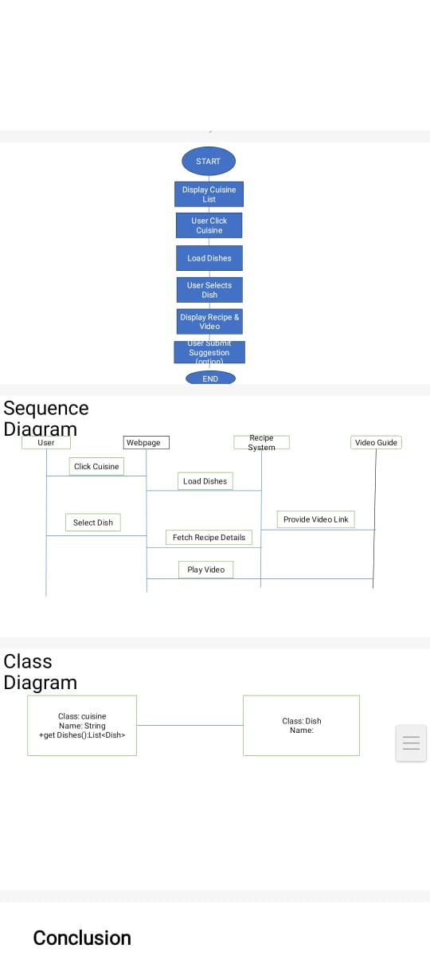

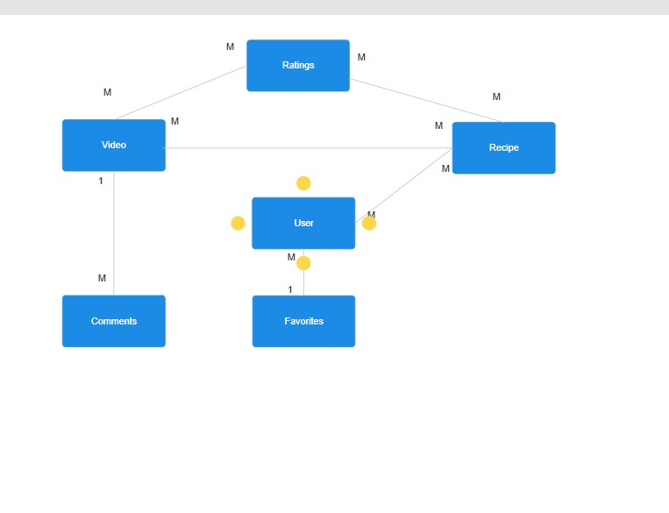

**4.Implementation**

**4.1Source code**

<!DOCTYPE html>

<html lang="en">

<head>

<meta charset="UTF-8" />

<meta name="viewport" content="width=device-width, initial-scale=1.0"/>

<title>Bite Buzz</title>

<style>

body {

font-family: 'Segoe UI', sans-serif;

background: #fff9f0;

color: #333;

margin: 0;

padding: 0;

}

header {

background-color: #ff7043;

padding: 20px;

text-align: center;

color: white;

}

header h1 {

margin: 0;

font-size: 2.5em;

}

.container {

padding: 20px;

max-width: 1000px;

margin: auto;

}

.grid {

display: flex;

flex-wrap: wrap;

gap: 15px;

justify-content: center;

}

.card {

background-color: #fff3e0;

border-radius: 8px;

padding: 20px;

text-align: center;

width: 180px;

box-shadow: 0 4px 6px rgba(0,0,0,0.1);

cursor: pointer;

transition: transform 0.2s;

}

.card:hover {

transform: scale(1.05);

background-color: #ffe0b2;

}

.back-btn {

margin-top: 20px;

display: inline-block;

text-decoration: none;

color: #e53935;

font-weight: bold;

}

.recipe-section {

background-color: #fff;

border: 1px solid #ddd;

border-radius: 8px;

padding: 20px;

margin-bottom: 20px;

}

.suggestion-box {

margin-top: 40px;

padding: 20px;

background-color: #f1f8e9;

border-radius: 8px;

}

textarea {

width: 100%;

padding: 10px;

border-radius: 5px;

resize: vertical;

}

button {

margin-top: 10px;

background-color: #66bb6a;

border: none;

color: white;

padding: 10px 20px;

border-radius: 5px;

cursor: pointer;

}

button:hover {

background-color: #43a047;

}

</style>

</head>

<body>

<header>

<h1>🍽️ Bite Buzz</h1>

<p>Explore popular cuisines with easy recipes & video guides</p>

</header>

<div class="container" id="main-content">

<!-- Cuisine cards will go here -->

</div>

<script>

const cuisines = {

"Italian": [

{

name: "Pasta",

steps: "1. Boil pasta\n2. Prepare sauce\n3. Mix and serve",

video: "https://youtu.be/sample1"

},

{

name: "Pizza",

steps: "1. Make dough\n2. Add toppings\n3. Bake in oven",

video: "https://youtu.be/sample2"

}

],

"Indian": [

{

name: "Butter Chicken",

steps: "1. Marinate chicken\n2. Cook in butter sauce\n3. Serve with naan",

video: "https://youtu.be/sample3"

},

{

name: "Biryani",

steps: "1. Cook rice\n2. Prepare masala\n3. Layer and steam",

video: "https://youtu.be/sample4"

}

],

"Mexican": [

{

name: "Tacos",

steps: "1. Make tortilla\n2. Add meat & veggies\n3. Serve with salsa",

video: "https://youtu.be/sample5"

},

{

name: "Quesadilla",

steps: "1. Fill tortilla with cheese\n2. Grill until crispy",

video: "https://youtu.be/sample6"

}

],

"Chinese": [

{

name: "Fried Rice",

steps: "1. Cook rice\n2. Stir fry with vegetables\n3. Add soy sauce",

video: "https://youtu.be/sample7"

}

],

"Thai": [

{

name: "Pad Thai",

steps: "1. Soak rice noodles\n2. Stir-fry with shrimp & sauce",

video: "https://youtu.be/sample8"

}

],

"Japanese": [

{

name: "Sushi",

steps: "1. Prepare rice\n2. Add fish/veggies\n3. Roll & slice",

video: "https://youtu.be/sample9"

}

],

"Korean": [

{

name: "Bibimbap",

steps: "1. Cook rice\n2. Add toppings\n3. Mix with gochujang",

video: "https://youtu.be/sample10"

}

],

"French": [

{

name: "Croissant",

steps: "1. Make layered dough\n2. Shape & bake",

video: "https://youtu.be/sample11"

}

],

"American": [

{

name: "Burger",

steps: "1. Grill patty\n2. Assemble with bun & toppings",

video: "https://youtu.be/sample12"

}

],

"Mediterranean": [

{

name: "Hummus",

steps: "1. Blend chickpeas\n2. Add olive oil & tahini\n3. Serve with pita",

video: "https://youtu.be/sample13"

}

]

};

const main = document.getElementById("main-content");

function loadHome() {

main.innerHTML = `<div class="grid">

${Object.keys(cuisines).map(cuisine =>

`<div class="card" onclick="loadCuisine('${cuisine}')">${cuisine}</div>`

).join('')}

</div>`;

}

function loadCuisine(cuisine) {

const dishes = cuisines[cuisine];

main.innerHTML = `

<h2>${cuisine} Recipes</h2>

${dishes.map(dish => `

<div class="recipe-section">

<h3>${dish.name}</h3>

<p><strong>Instructions:</strong><br>${dish.steps.replace(/\n/g, "<br>")}</p>

<a href="${dish.video}" target="_blank">🎥 Watch Video</a>

</div>

`).join('')}

<a class="back-btn" onclick="loadHome()">⬅ Back to Cuisines</a>

${suggestionBox()}

`;

}

function suggestionBox() {

return `

<div class="suggestion-box">

<h3>💡 Suggest a Recipe</h3>

<textarea id="suggestionText" placeholder="Enter your suggestion here"></textarea>

<button onclick="submitSuggestion()">Submit</button>

</div>

`;

}

function submitSuggestion() {

const value = document.getElementById("suggestionText").value;

if(value.trim() === "") {

alert("Please write a suggestion first.");

} else {

alert("Thank you for your suggestion!");

document.getElementById("suggestionText").value = "";

}

}

// Load homepage on start

loadHome();

</script>

</body>

</html>

**5.Results**

The Bite Buzz web application was successfully developed and tested based on the defined requirements. The system meets its objective of providing a curated and interactive recipe browsing experience for users.

Key Outcomes:

A fully functional single-page application (SPA) built using React

Users can explore 10 popular cuisines, each containing a list of famous dishes.

Each dish includes:

Step-by-step instructions

A link to a video guide

A Suggestion Box allows users to give feedback or ideas for new content.

The user interface is responsive, visually appealing, and easy to navigate.

The application runs smoothly on major browsers like Chrome and Edge without requiring any backend setup.

**5.1Output Screens**

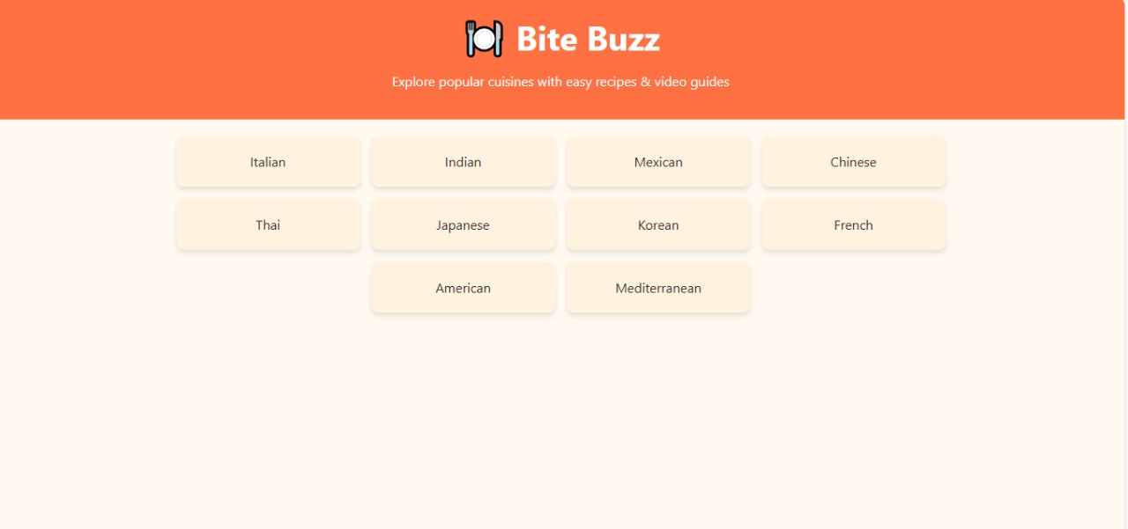

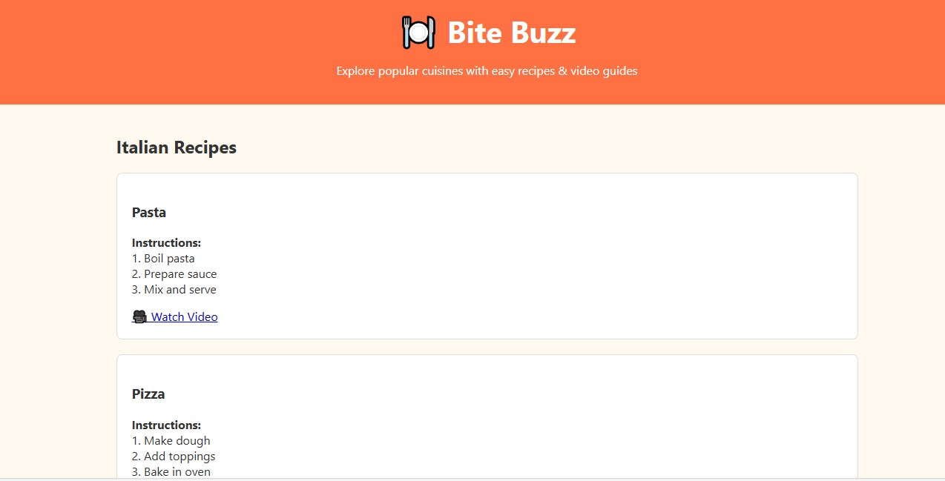

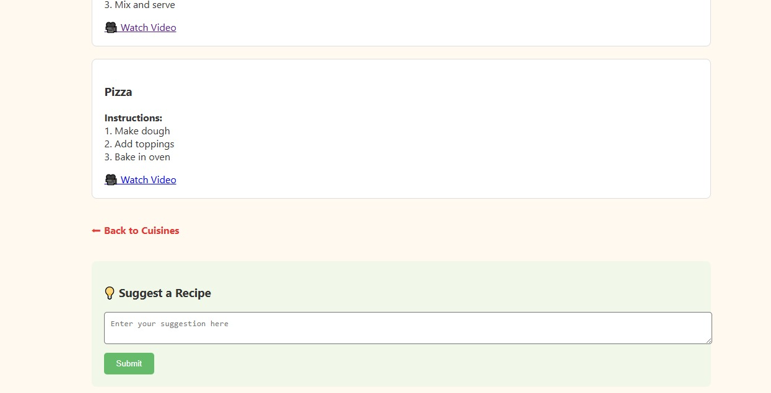

**6.Conclusions:**

The **Bite Buzz** project successfully demonstrates the development of a responsive and interactive web application focused on exploring food recipes from various cuisines. Built entirely using front-end technologies like **HTML**, **CSS**, and **React.js**, the application offers users a seamless experience to browse recipes, view preparation steps, and watch video tutorials.

With features such as a categorized cuisine layout, detailed recipe views, and a suggestion box for user feedback, Bite Buzz emphasizes usability and content accessibility. The implementation proves that even without a backend or database, effective and engaging web solutions can be developed using modern client-side frameworks.

This project has not only met the initial goals but also provides a solid foundation for future enhancements, such as chatbot integration or database connectivity, making it a scalable and practical solution for recipe-based platforms.

**7.References**

**7.1. React Official Documentation**

[https://reactjs.org/docs/getting-started.html](https://reactjs.org/docs/getting-started.html)

**7.2. MDN Web Docs – HTML, CSS, JavaScript**

[https://developer.mozilla.org/](https://developer.mozilla.org/)

**7.3. W3Schools – Web Development Tutorials**

[https://www.w3schools.com/](https://www.w3schools.com/)